Distance Learning Ideas Without Screens

Sorting | Children can sort anything! Make a rule to sort your objects. Sort by size, color, shape, animals, etc.  Some things to sort: stuffed animals, socks, shoes, silverware, crayons/markers, cards, coins, toys, hair bows, etc.
Make a Pattern | Have your children find objects to make patterns with. Make patterns using colors, shapes, numbers, stickers, stamps, toys, game pieces, food, rocks, body movements, etc.  Some examples of patterns:  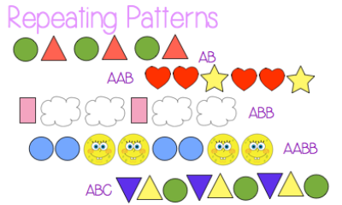
Play Double Compare | This game is played with a deck of cards just like the game of “war”; it just has an extra step.  - Shuffle the cards and split it into two piles. (each player gets 1 pile)  - Instead of each player flipping 1 card, each player flips 2 cards.  - Both players either add, subtract, or multiply their own cards.  - Then they compare their answers.  - The player with the greater answer - keeps all 4 cards.  - If both players have the same answer - each player should flip two more cards and repeat the above steps.
Play a game | There are a lot of games that practice math skills. Some reinforce counting the number of spaces, while others include more sophisticated math skills and reinforce strategy play.  Examples: Monopoly, Yahtzee, Sorry, Clue, Trouble, Qwirkle, Set, Chess, Checkers, Uno, Rummy, Football Showdown, Rush Hour  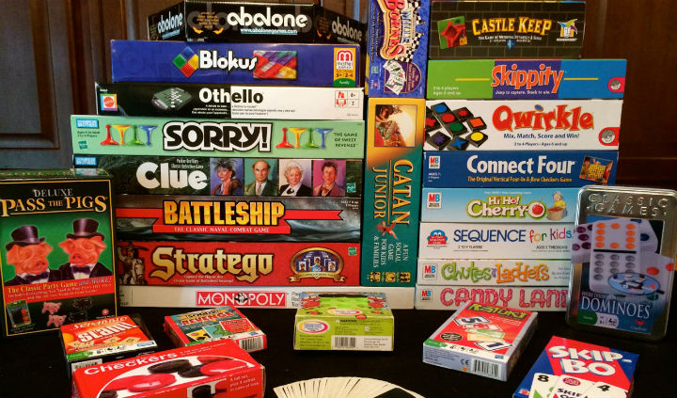
Play Go Fish for partners of 10 | This follows the original rules of Go Fish, with one little twist.  - Shuffle the cards and deal each player 5 cards.  - Instead of looking for pairs (6 and 6), you are looking for 2 cards that make 10 (4 and 6).  - If you have any partners that make 10, you can take those out of your hand and put them in a pile.  - Then play continues with each player asking another for a specific card that would “make ten” with a card from their own hand.  - The player with the most “partners of 10” at the end wins the game.
Race to 100 | Option 1: In this game, you use a die to roll. You can simply keep rolling your die and adding to your total until you get to 100 keeping track of your equations/calculations.  Option 2: Play with a partner. See who can get to 100 with the fewest rolls.
Create a graph | This is a great way to use your resources at home. You can tally and graph anything. Some ideas of things to graph are below.  - Types and number of shoes in your house  - Types and number of flowers you see out of your window  - Types and number of food items in your cabinet  - Color and number of cars that pass your window over a period of time
Counting Collections | Anything can be counted! Challenge to see how high you can get! One suggestion - make sure to organize your count so that you can keep track and add on (groups of 5, 10, 25, 50, 100, 1000).  Examples of things to count around the house: canned goods, legos, stuffed animals, toy cars, beans, pasta, crayons, leaves on a plant, Q-Tips, cotton balls  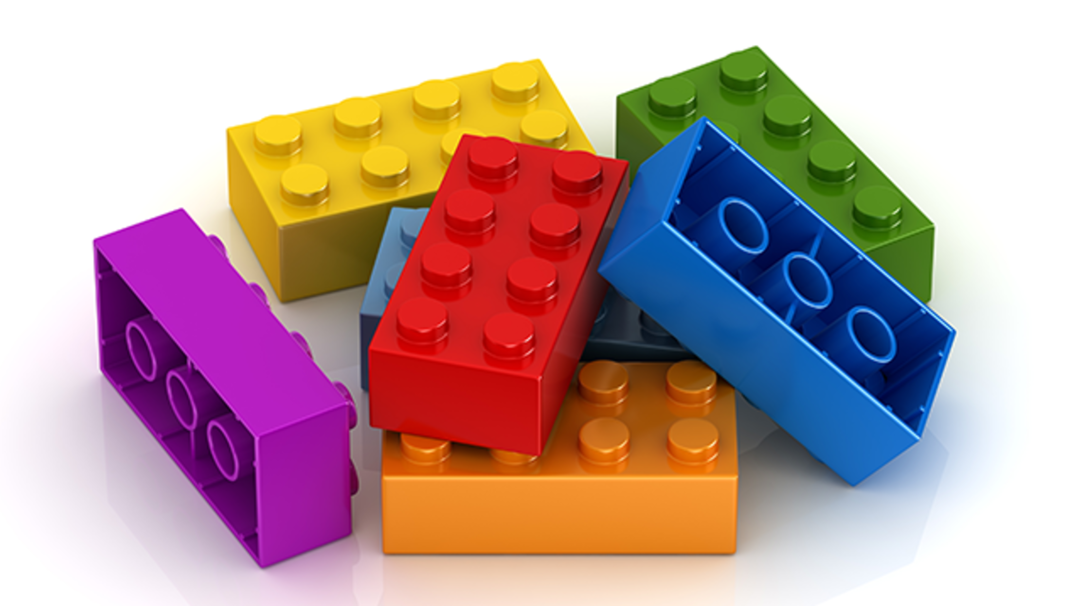
Write story problems | Write story problems for each other to solve. Add in multiple steps to make it more challenging.
Practice Telling Time and Elapsed Time | Time is a concept that we use everyday. We can build in opportunities throughout the day for opportunities for kids to check the clock and tell time, and figure out how many minutes until their next activity.  - Create a schedule for your day and keep track of the clock  - Estimate how much time is needed for an activity and calculate the difference between the actual time and the estimate.  - Calculate the elapsed time between activities.
Practice Sorting and Counting Coins and Bills | 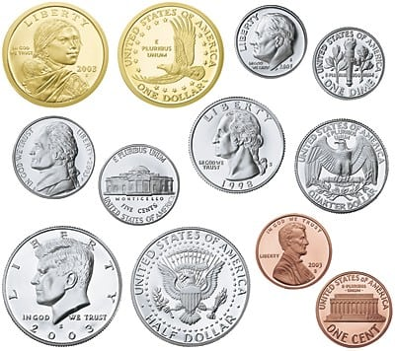  It is always fun to work and play with money. Some ideas to reinforce important math skills are below.  - Identify coins and their values  - Count to find an exact amount  - Pay and make exact change  - Set up a pretend store  - Create pretend money with your own pictures  - Exchange amounts (1$ in quarters exchanged for 1$ in dimes and nickels).

